**Introduction To OOPs**

**(JAVA Programming)**

**UET Peshawar**

**Department Of Computer Science**

**2nd Semester (spring)**



**Lab 1 Tasks**

**Assingment N0. 01**

**Submitted By:**

Waqas Khan s/o Azeem Khan

RegNo : 24pwbcs1141

**Submitted To:**

Sir Syed Adeel Ali Shah Associate Professor CS&IT Peshawar

### Exercise 1: Setting Up Your First Java Program

1. **Task**: Create a new project in IntelliJ, and write a Java program that prints “Hello,World!”.

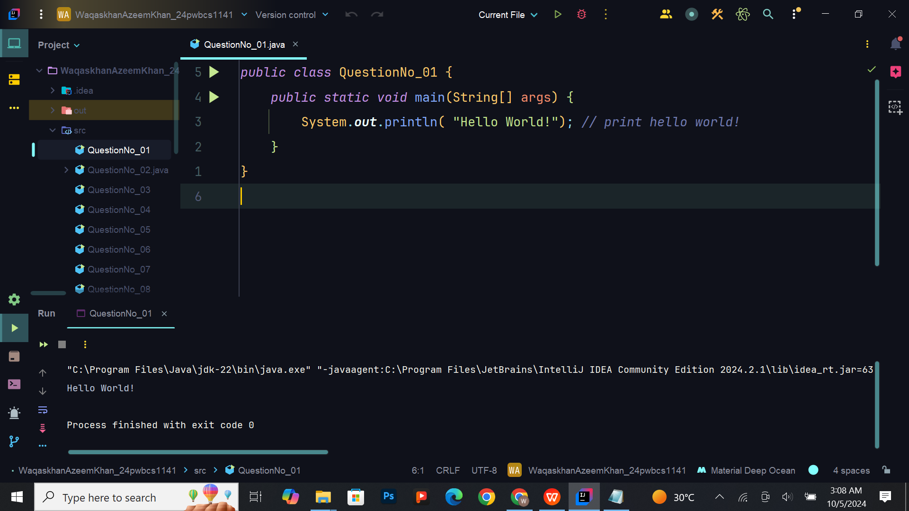

## Exercise 2: Declaring a Class and Main Method

**Task:** Declare a new class named FirstClass and within that, declare the main methods discussed in the lecture.

**Expected Output:** No specific output required yet, but the code should compile without errors.

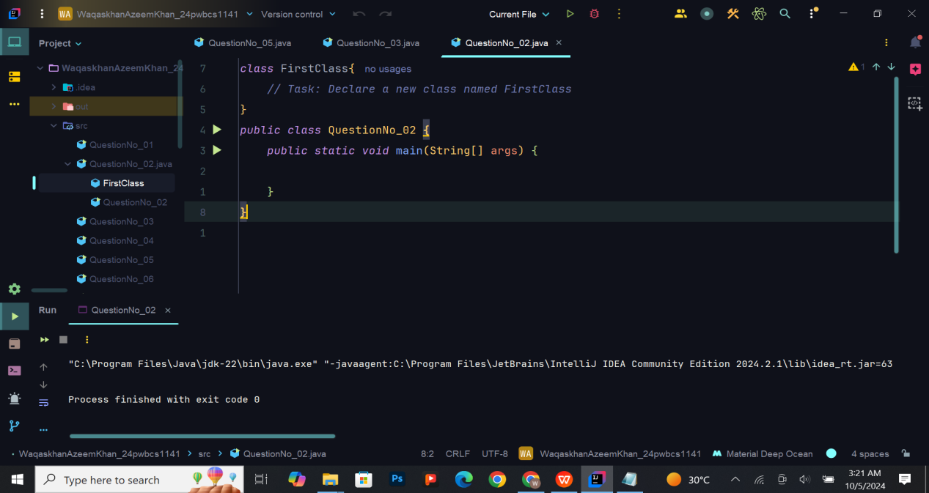

## Exercise 3: Understanding Code Blocks and Statements

**3. Task:** Within the main method, write a statement that outputs your name to the console using System.out.println().

**Expected Output:**

My name is [Your Name].

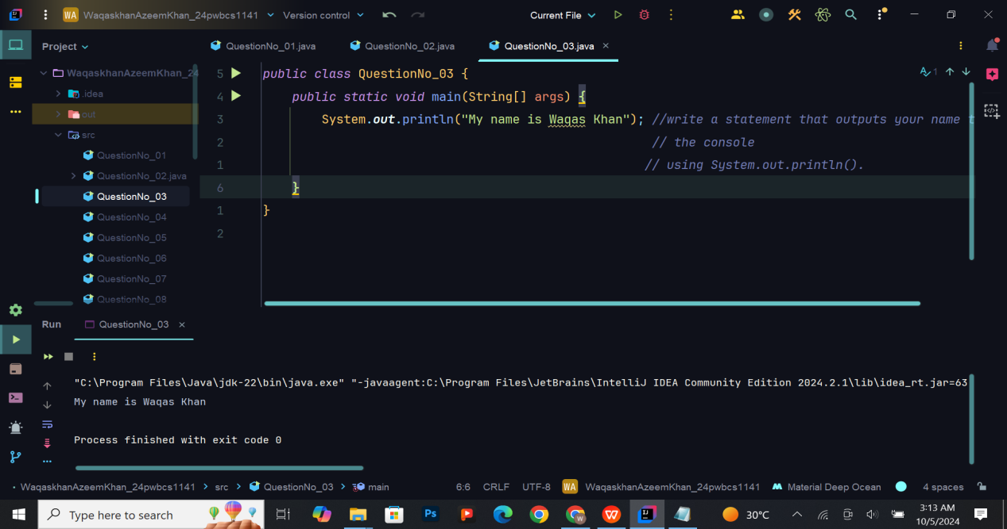

## Exercise 4: Declaring Variables and Printing Their Values

**5.Task**: Declare an integer variable age and set its value to your age. Then, print it using System.out.println().

Expected Output: My age is: [Your Age]

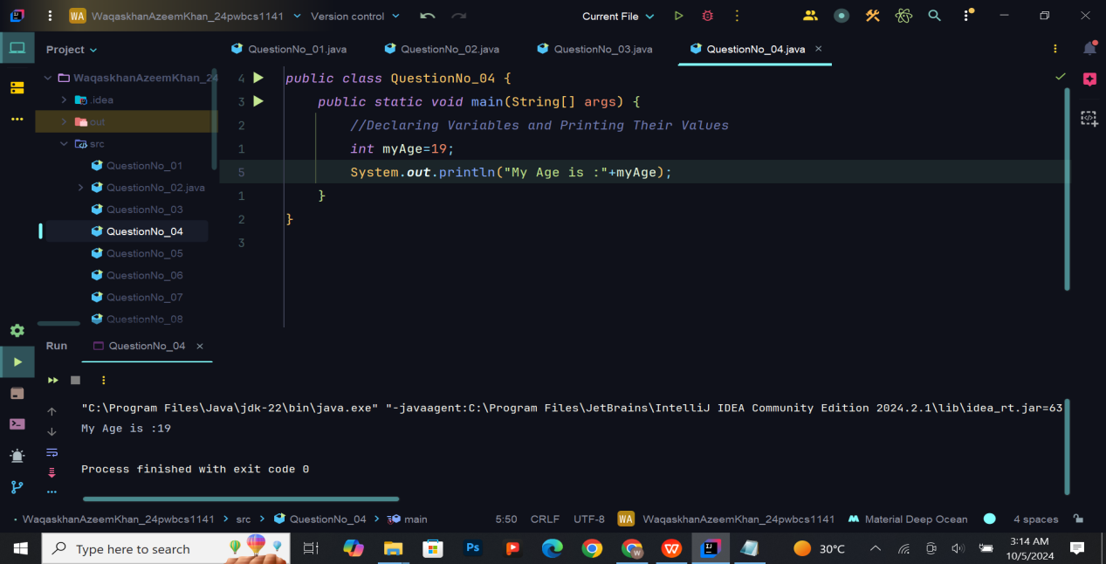

## Exercise 5: Working with Primitive Data Types

**5. Task**: Declare variables for different data types: byte, short, int, long, float, double,char, and boolean. Assign values to each and print them.

**Expected Output:**

Byte value: [Your Byte Value]

Short value: [Your Short Value]

Int value: [Your Int Value]

Long value: [Your Long Value]

Float value: [Your Float Value]

Double value: [Your Double Value]

Char value: [Your Char Value]

Boolean value: [Your Boolean Value]

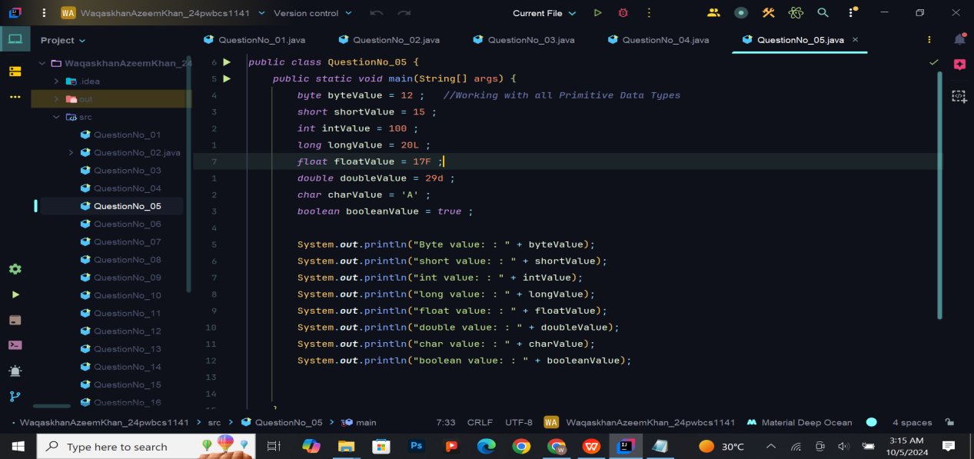

**Output:**

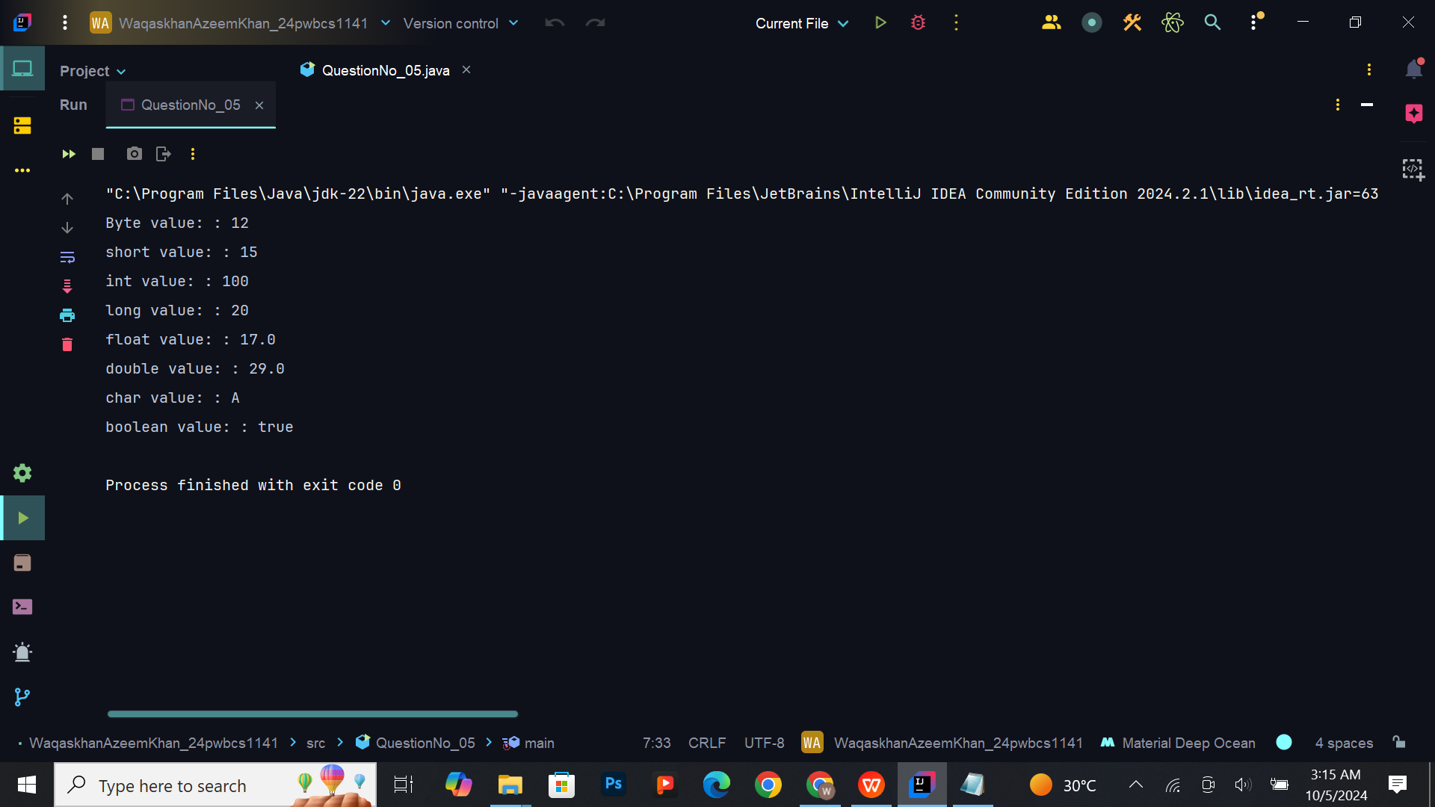

## Exercise 6: Wrapper Classes and MIN/MAX Values

1. **Task:** Use the wrapper class for int (Integer) to print the minimum and maximum values.

**Hint**: Use Integer.MIN_VALUE and Integer.MAX_VALUE.

**Expected Output**:

Min int value: -2147483648

Max int value: 2147483647

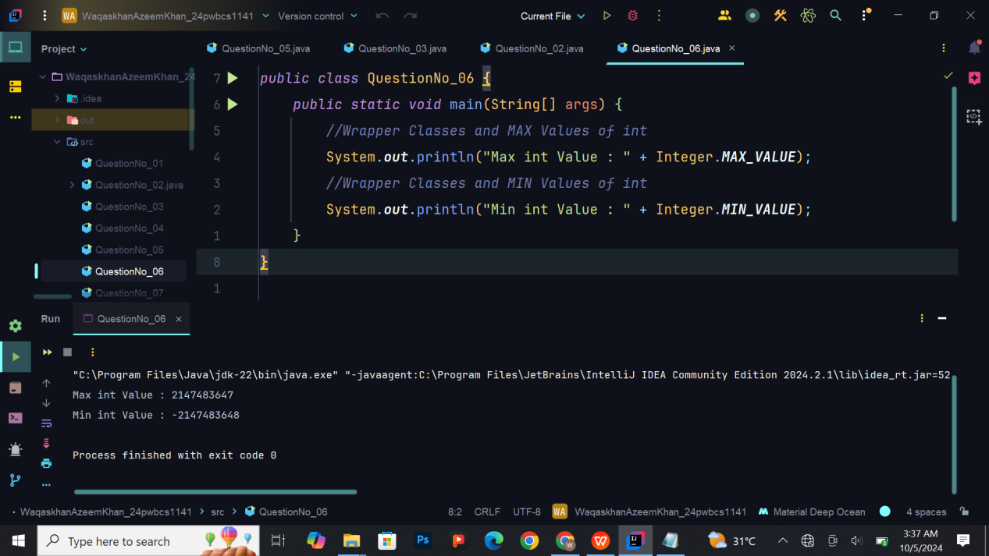

## Exercise 7: Demonstrating Overflow and Underflow

1. **Task:** Assign the value 2147483647 to an int variable and add 1. Print the result to observe overflow. Repeat for a byte variable.

**Expected Output:**

Maximum value of int: [originally assigned value]

Maximum value of byte: [originally assigned value]

Overflow example with int: [Overflowed Value]

Overflow example with byte: [Overflowed Value]

Underflow example with int: [Underflowed Value]

Underflow example with byte: [Underflowed Value]

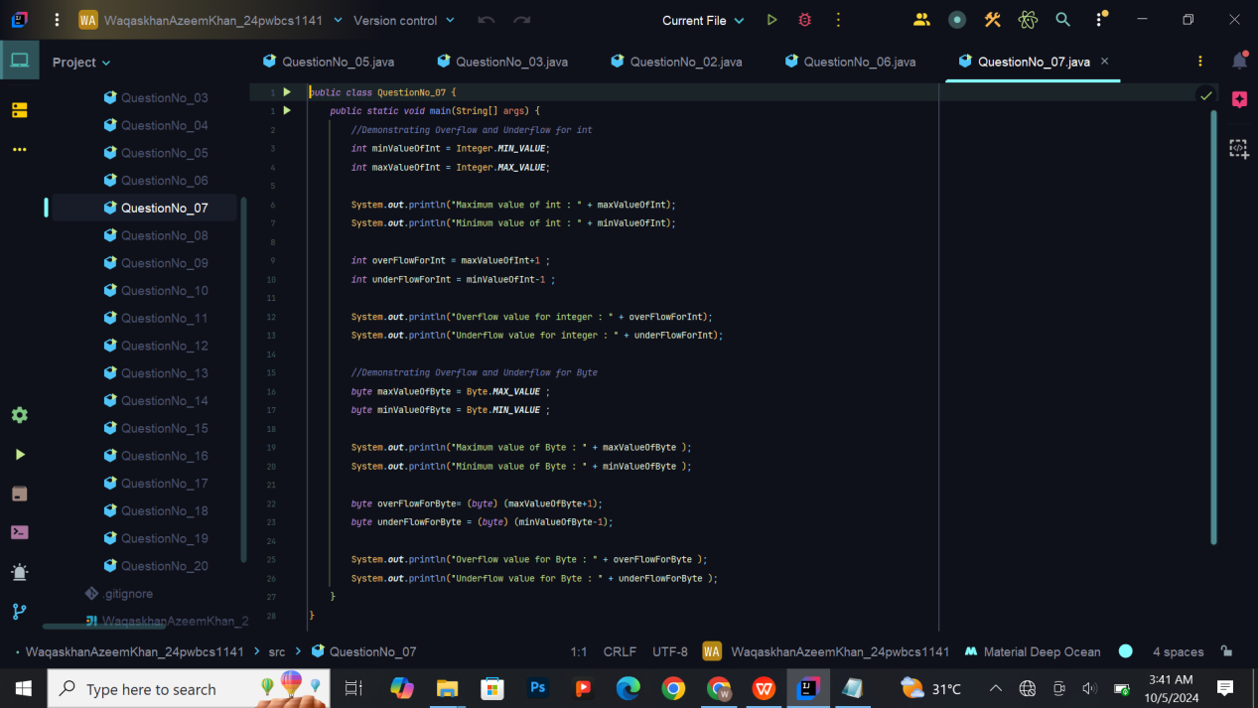

**Output :**

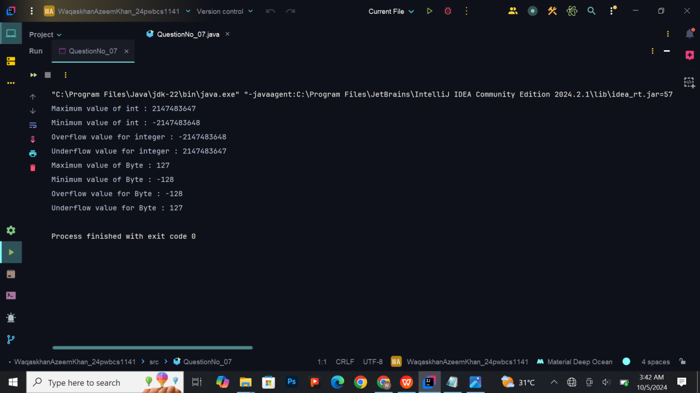

## Exercise 8: Working with Long and Double

1. **Task**: Declare a long variable with the value 10000000000L and a double variable with a value of your choice. Print both values. Demonstrate why adding L is important for long data types.

**Expected Output:**

Long value: 10000000000

Double value: [Your Double Value]e.

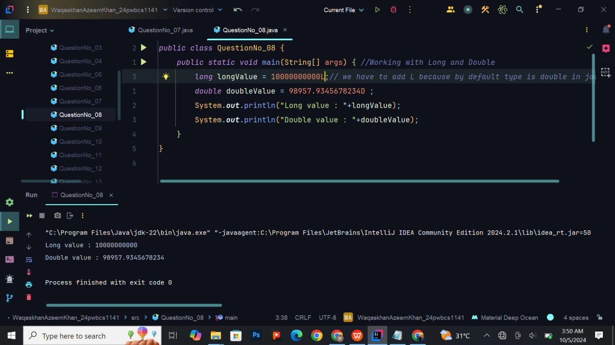

## Exercise 9: Conversion between Types (Casting)

1. **Task:** Convert a double value (e.g., 5.99) to an int and print the result.

**Expected Output:**

Double value: 5.99

After casting to int: 5

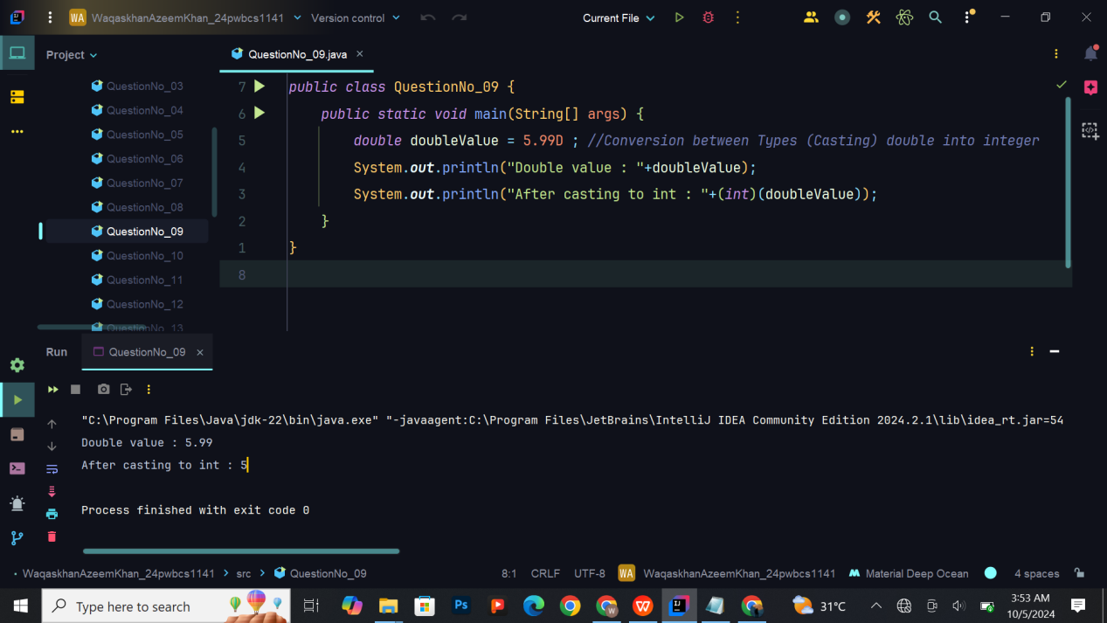

## Exercise 10: Converting Pounds to Kilograms

1. **Task**: Write a program to convert pounds to kilograms (1 pound = 0.45359237 kg). Declare a double variable for pounds and calculate the equivalent kilograms. Print both values.

**Expected Output:**

Pounds: [Your Pounds Value]

Kilograms: [Calculated Kilograms]

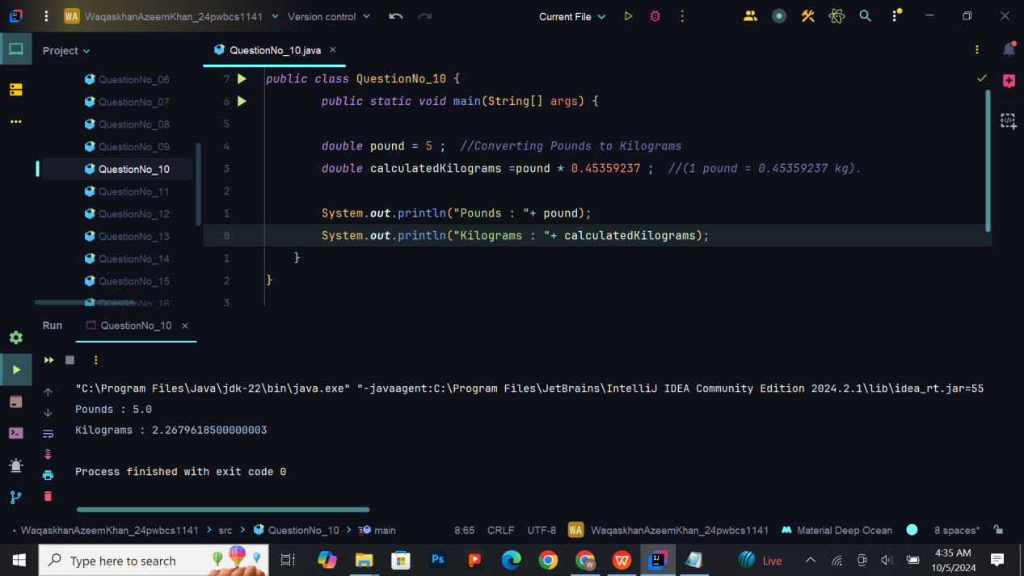

## Exercise 11: Working with Char and Boolean

1. **Task:** Declare a char variable and assign a Unicode character. Also, declare a boolean variable and assign it true. Print both values.

**Expected Output:**

Char value: [Your Unicode Character]

Boolean value: true

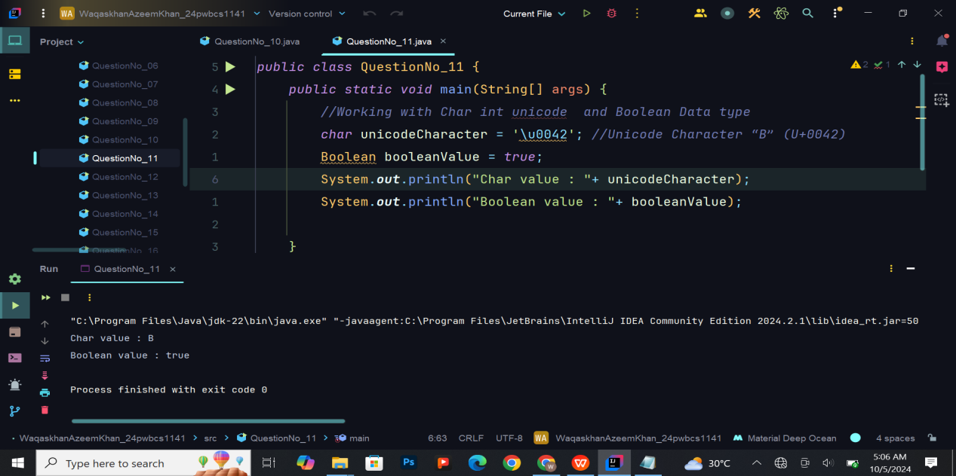

## Exercise 12: Basic Conditional Logic (if-else)

1. **Task**: Write an if-else statement that checks whether a number is greater than 10. If it is, print “Number is greater than 10”; otherwise, print “Number is less than or equal to 10.”

**Expected Output:**

Number is [Condition Result]

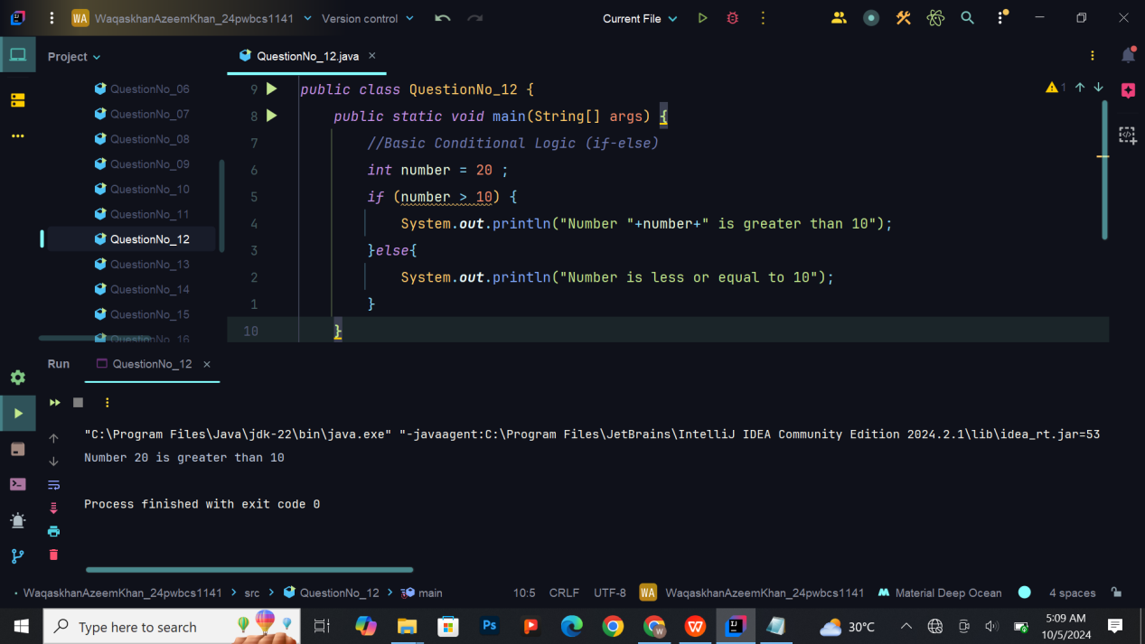

## Exercise 13: Using Ternary Operator

1. **Task**: Use a ternary operator to check whether a boolean value is Available is true or false, and print the result.

**Expected Output:**

Availability: [true/false]

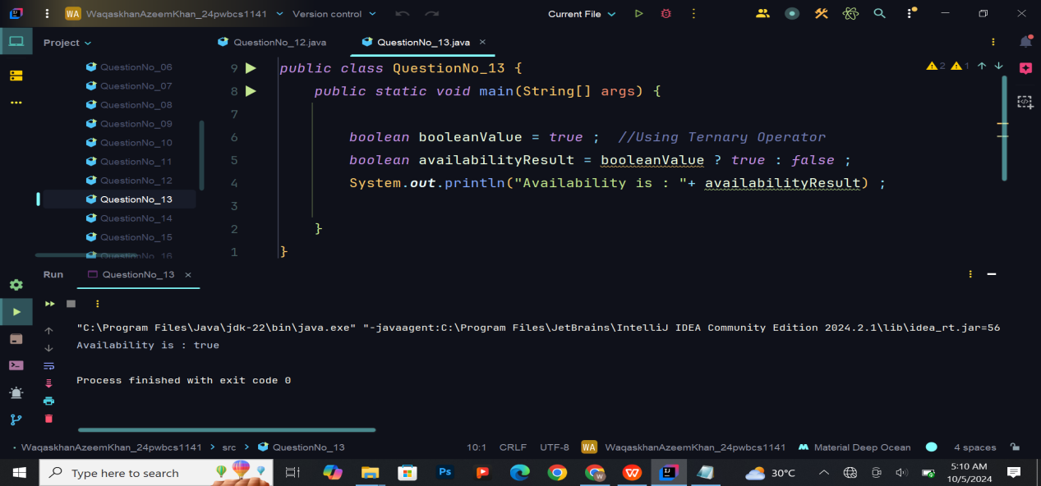

## Exercise 14: Exploring Strings

**14. Task:** Declare a String variable and assign a value to it. Print the string, and then reassign a new value and print again to observe the immutability of strings.

**Expected Output:**

Initial String: [Your String]

Modified String: [New String]

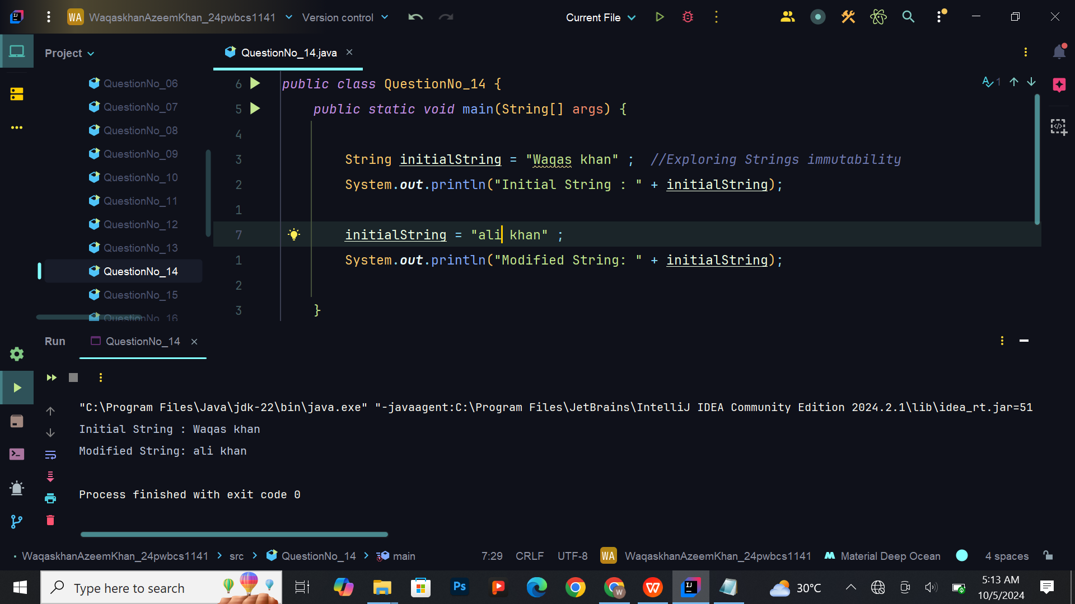

## Exercise 15: Conclusion and Cleanup

15 Task: Go through all your code, ensure it compiles and runs correctly, and print any final messages or observations you have made during the lab session.

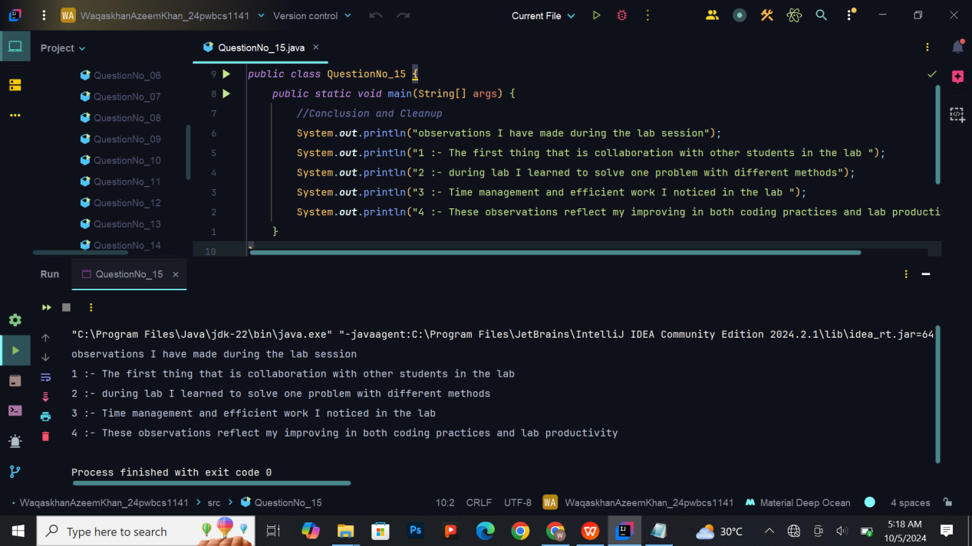

## Exercise 16: Simple Calculator

**Task:** Write a program that acts as a basic calculator. It should take two integers and perform addition, subtraction, multiplication, and division on them. Use int data types for inputs and the result.

**Hint:** You can hardcode the values for this exercise.

**Expected Output:**

Number 1: [Your First Number]

Number 2: [Your Second Number]

Addition: [Result of Addition]

Subtraction: [Result of Subtraction]

Multiplication: [Result of Multiplication]

Division: [Result of Division]

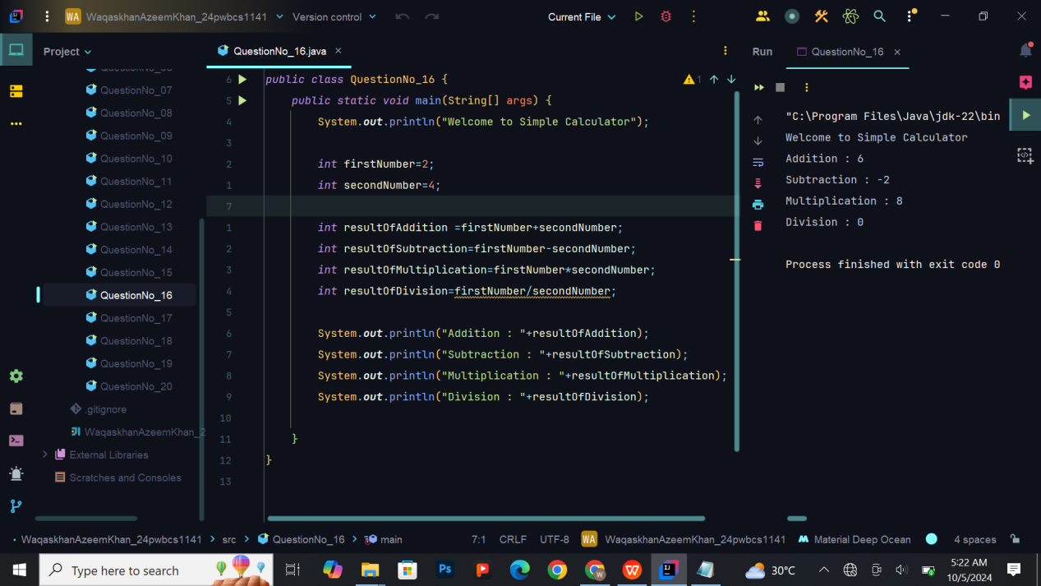

## Exercise 17: Area and Perimeter of a Rectangle

**Task**: Write a program that calculates the area and perimeter of a rectangle. Use two int variables for length and width, and calculate the area (length * width) and perimeter (2 * (length + width)).

**Expected Output:**

Length: [Your Length Value]

Width: [Your Width Value]

Area: [Calculated Area]

Perimeter: [Calculated Perimeter]

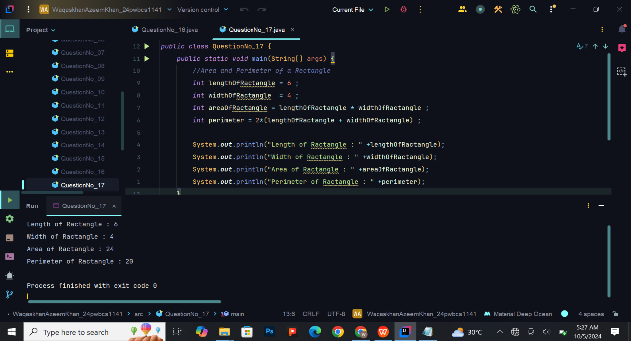

## Exercise 18: Temperature Converter (Celsius to Fahrenheit)

**Task**: Create a program that converts temperature from Celsius to Fahrenheit using the formula:

Fahrenheit = (Celsius * 9/5) + 32.

**Hint:** Use double variable for the Celsius input and the Fahrenheit result.

**Expected Output:**

Celsius: [Your Celsius Value]

Fahrenheit: [Calculated Fahrenheit]

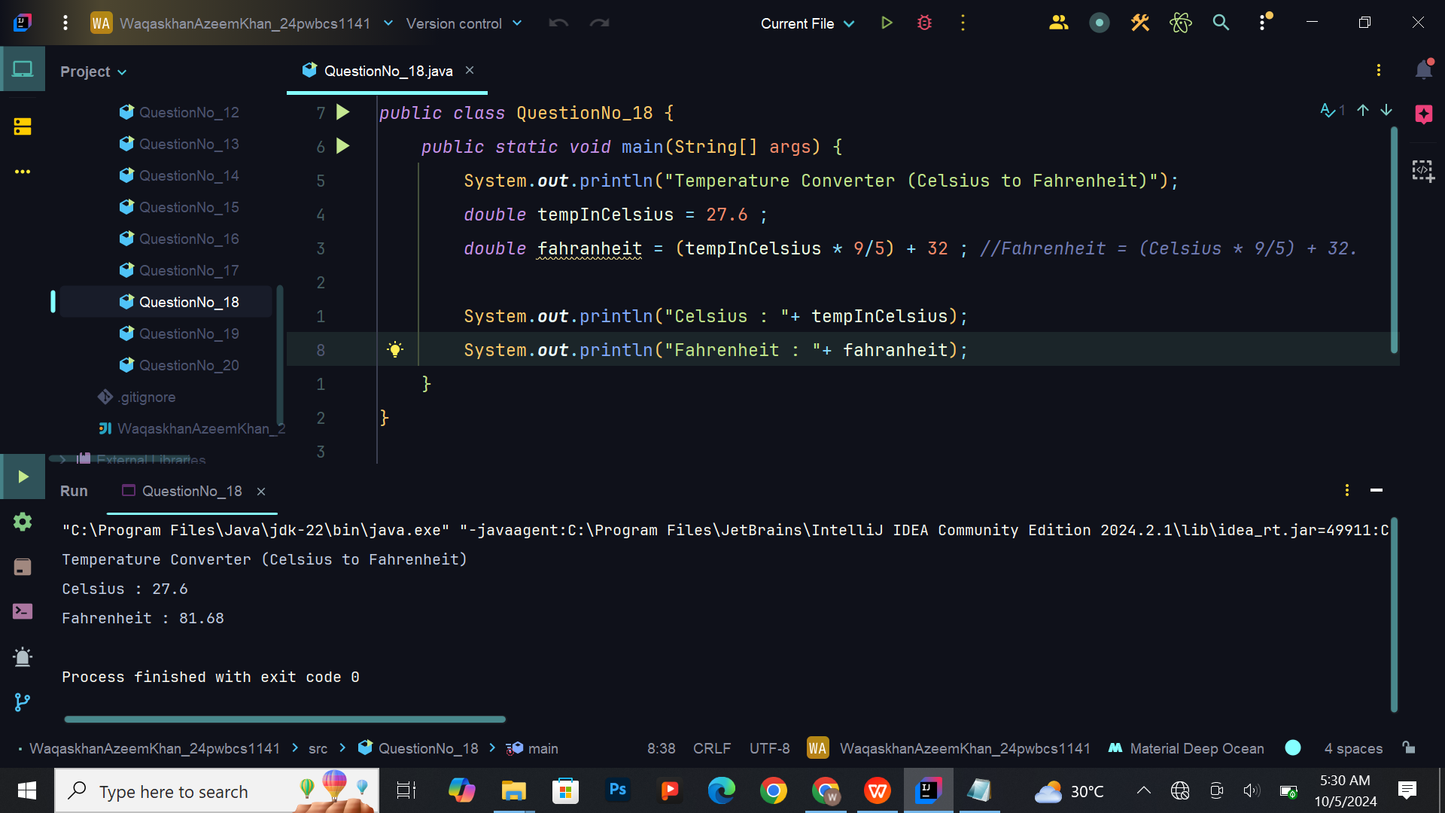

## Exercise 19: Sum of Digits

**Task:** Write a program that takes a three-digit number and calculates the sum of its digits.

For example, if the input is 123, the sum will be 1 + 2 + 3 = 6

.**Hint:** Use arithmetic operators like division (/) and modulus (%) to extract digits

**Expected Output:**

Input number: [Your Input Number]

Sum of digits: [Calculated Sum]

## Screenshot (609)

## Exercise 20: Grade Calculator

**Task:** Write a program that takes a student 60 marks out of 100 and calculates the grade based on the following conditions:

Marks >= 90: Grade A

Marks >= 80: Grade B

Marks >= 70: Grade C

Marks >= 60: Grade D

Marks < 60: Grade F

**Hint:** Use if-else statements

.

**Expected Output:**

Marks: [Your Marks]

Grade: [Calculated Grade]

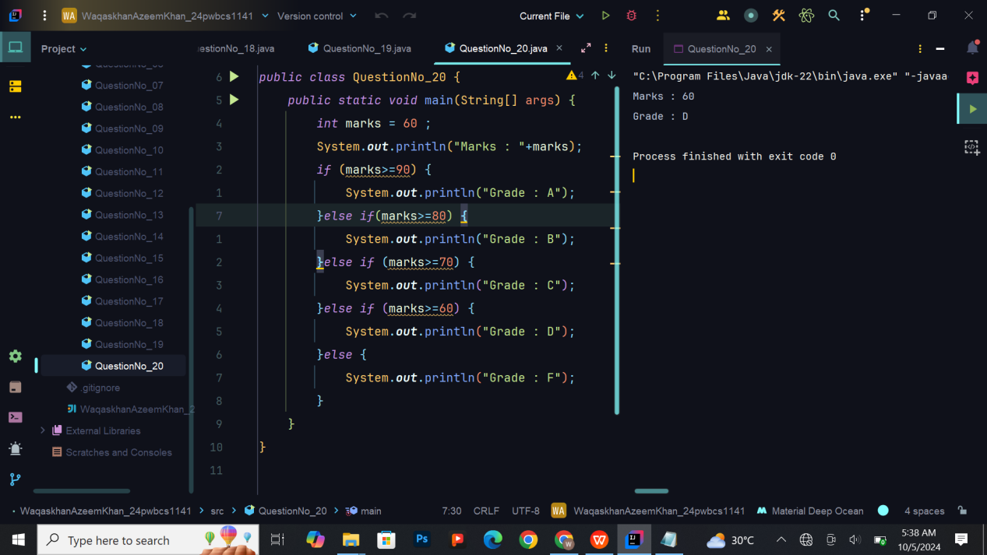

# The End!…